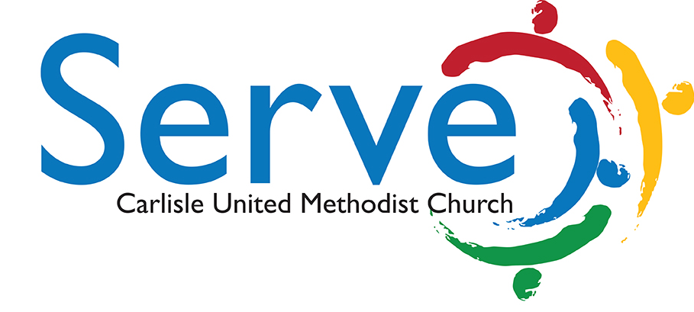

Opportunity: Serve: Fruitbelt Farmworkers Team

Description: Share love with migrant farmworkers in Adams County through the sharing of a meal and basic gifts that will improve their life in Arendstville, Adams County.

Time: Commitment to visit the farm with the team in September or October at least twice

Reports to: Robyn Khron rlbk53@gmail.com

- Visit the farm to deliver donations of sweatshirts, blankets, health kits, etc. as provided by the congregation in September.
- Help prepare and share a meal with the farmworkers in October one Sunday afternoon.
- Share in worship with the farmworkers, giving them Spanish Bibles and singing songs together.
- Play games together such as soccer, horseshoes, softball, cards, or Bingo for an evening.

